MATCH AND SOLVE
Match the Braille words with the correct pictures

DOG | 
CAT | 
SEAHORSE | 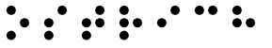
PENGUIN | 
OSTRICH | 

ZEBRA | 
GOLDFISH  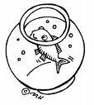 | 
ELEPHANT  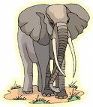 | 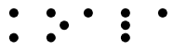
HORSE  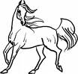 | 
KOALA  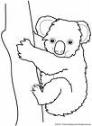 | 